**Name:شريف اشرف سيد بدر**

**Course code: ECE001**

**Date: 2019_2020**

**BN: 416**

**Title: programming languages**

Github-link [**https://github.com/shereef-ashraf/HTML-Project-Repository**](https://github.com/shereef-ashraf/HTML-Project-Repository)

Github-pages( published websit)**:** [**https://shereef-ashraf.github.io/HTML-Project-Repository/**](https://shereef-ashraf.github.io/HTML-Project-Repository/)

Sectionscreenshots:

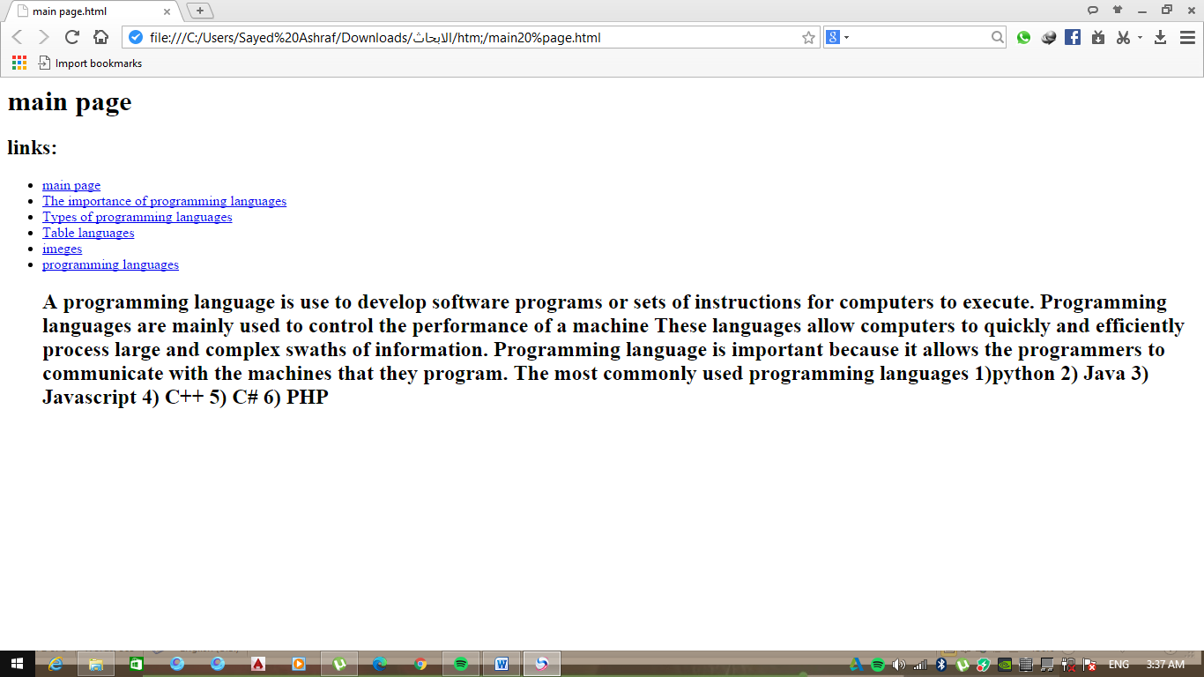

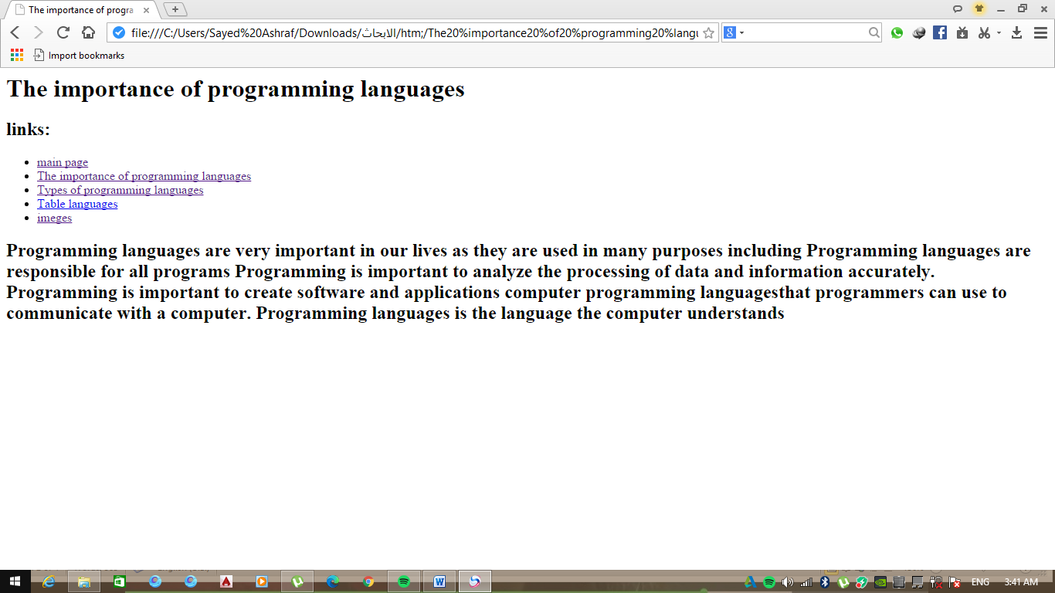

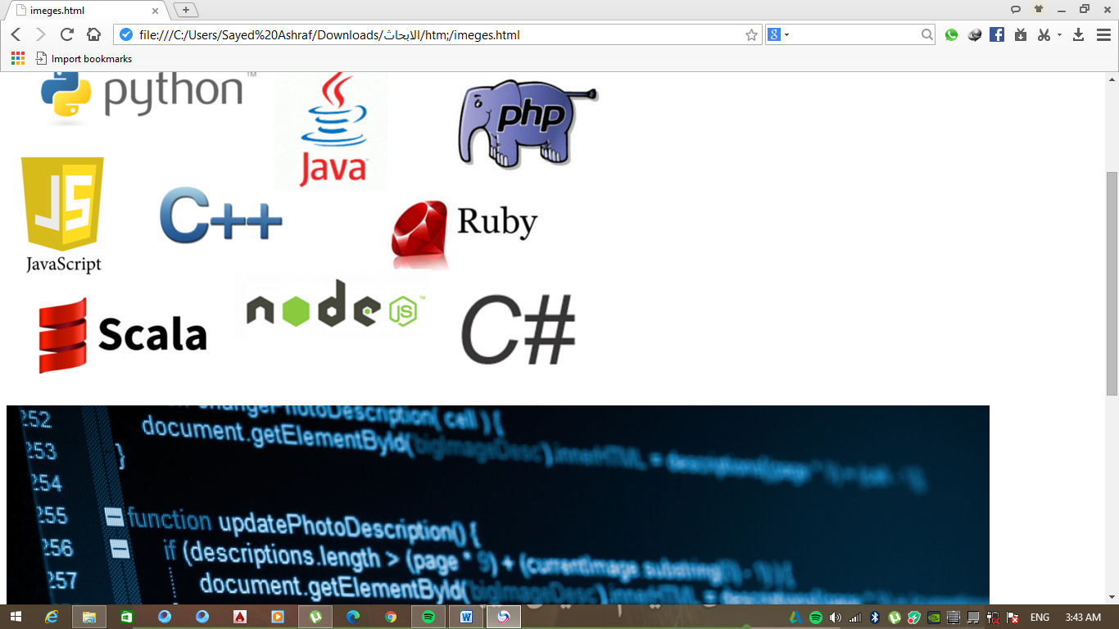

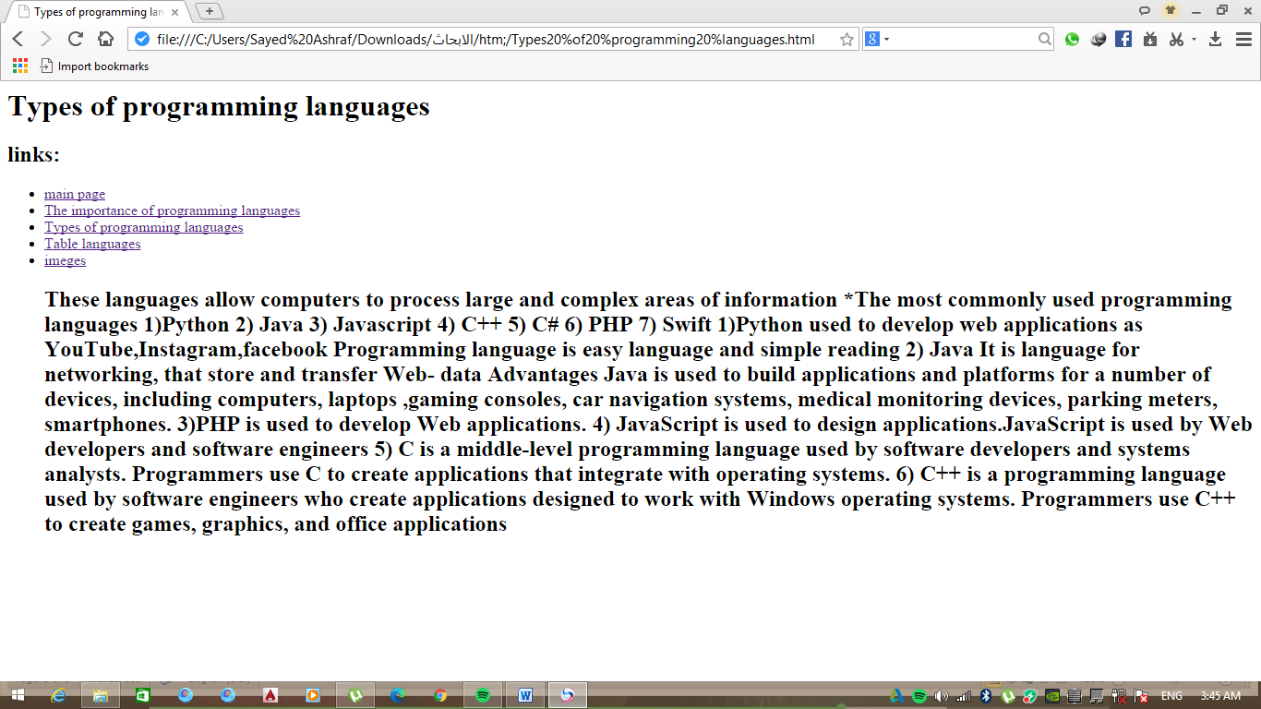

**Application brief:**

**Aprogramming language is a set of commands use to create a software programs.**

use to analyze the processing of data and information

**The importance of programming languages**

1. important to analyze the processing of data and information .
2. Programming is important to create software and applications that
3. programmers can use it to communicate with a computer.
4. Programming languages ​​is the language the computer understands
5. Programming languages are mainly used to develop software programs or sets of instructions for computers to execute.
6. Programming languages are mainly used to control the performance of a machine
7. These languages allow computers to quickly process large and complex swaths of information.
8. Programming language is important because it allows the programmers to communicate with the machines that they program.

**The most commonly used programming languages**

1)python 2) Java 3) Javascript 4) C++ 5) C# 6) PHP

**Python** used to develop web applications as YouTube,Instagram,facebook Programming language is easy language and simple reading

**2) Java** It is language for networking, that store and transfer Web- data Advantages Java is used to build applications and platforms for a number of devices, including computers, laptops ,gaming consoles, car navigation systems, medical monitoring devices, parking meters, smartphones.

**3)PHP** is used to develop Web applications**.**

**4) JavaScript** is used to design applications.JavaScript is used by Web developers and software engineers

**5) C#** is a middle-level programming language used by software developers and systems analysts. Programmers use C to create applications that integrate with operating systems.

**6) C++** is a programming language used by software engineers who create applications designed to work with Windows operating systems. Programmers use C++ to create games, graphics, and office applications